**GLENORA PRESCHOOL - REGISTRATION HIERARCHY**

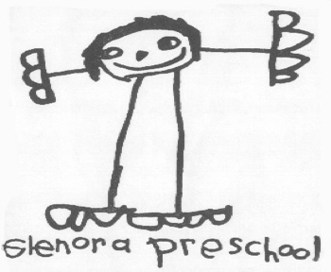

At Glenora Preschool our aim is to be community inclusive and we strive to create space for all families that wish to be a part of our program. That said, in the event that there are more applicant students than openings available, registration will be accepted based on the following priorities:

**3 Year Old AM Class Registration Priority**

1. Families with an older child who has already attended Glenora Preschool ("Legacy") who live within the neighbourhood boundary ("Interior")

2. First time Interior families

3. Legacy families who live outside of the neighbourhood boundary ("Exterior")

4. First time Exterior families

**4 Year Old AM Class Registration Priority**

1. Returning student from 3 year old AM Class

2. Returning student from 3 / 4 year old split PM Class

3. Legacy Interior

4. First time Interior

5. Legacy Exterior

6. First time Exterior

**3 / 4 Year Old Split PM Class Registration Priority**

1. Returning students from 3 / 4 year old split PM Class

2. Returning students from 3 year old AM Class

3. Legacy Interior

4. First time Interior

5. Legacy Exterior

6. First time Exterior

However, given the recent priority policy change in 2022, we have adopted a notice period applicable only to families living outside the neighbourhood boundary who had one or more children who were registered and attended Glenora Preschool in or before the 2022-2023 school year. These families shall maintain priority over new families located within the community boundary up until the 2025-2026 school year. As of the 2026-2027 school year, all families shall be considered according to the above priority list.

Questions? Contact [glenorapreschoolregistrar@gmail.com](mailto:glenorapreschoolregistrar@gmail.com)