**GLENORA PRESCHOOL - REGISTRATION HIERARCHY**

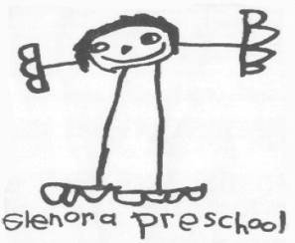

## Registration Hierarchy

At Glenora Preschool our aim is to be community inclusive and we strive to create space for all families that wish to be a part of our program. That said, in the event that there are more applicant students than openings available, registration will be accepted based on the following priorities:

### Year-old AM Class Registration Priority

### 

1. Families with an older child who has already attended Glenora Preschool ("Legacy")

2. First time families within the preschool boundaries

3. First time families outside the preschool boundaries

### Year-old AM Class Registration Priority

1. Returning student from 3 year old AM Class

2. Returning student from 3 / 4 year old split PM Class

3. Legacy families

4. First time families within the preschool boundaries

5. First time families outside the preschool boundaries

### 3 / 4 Year-old Split PM Class Registration Priority

1. Returning students from 3 / 4 year old split PM Class

2. Returning students from 3 year old AM Class

3. Legacy families

4. First time families within the preschool boundaries

5. First time families outside the preschool boundaries

Questions? Contact [glenorapreschoolregistrar@gmail.com](mailto:glenorapreschoolregistrar@gmail.com)